APIs: HTTP and JSON lab

AC0 Landing Zone


Contents
1. Postman 1
1.1. Installation 1
1.2. Creating your first request 3
1.3. Sending data 4
2. Python 9
2.1. Get request 9
2.2. POST request 11

Postman

Installation
- Start by going to the Postman downloads page: Download Postman | Get Started for Free.
- Click on the Windows x64 button to initiate the download.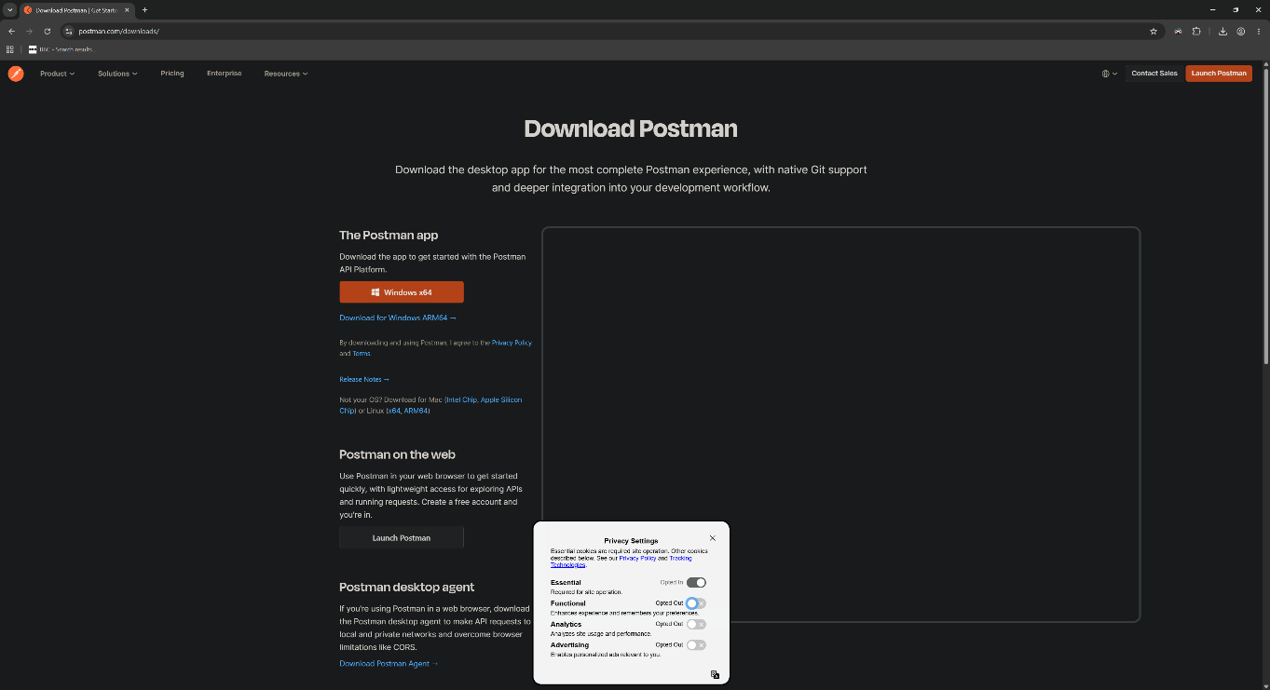

- Postman should open automatically, but if not simply double click on the Postman executable in your downloads folder: 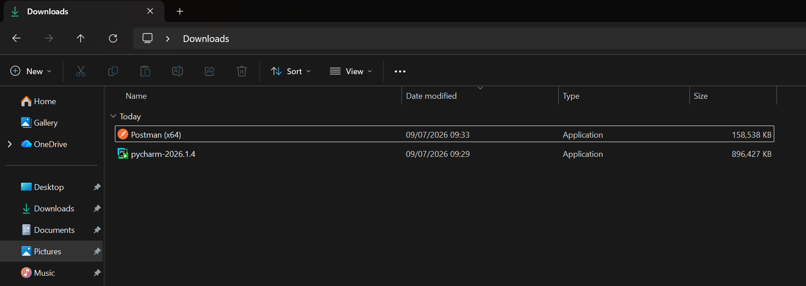

- When the Postman app opens, you will be prompted to sign up for an account. Simply click ‘Continue without account’ for now?
- Open the ‘lightweight API client’: 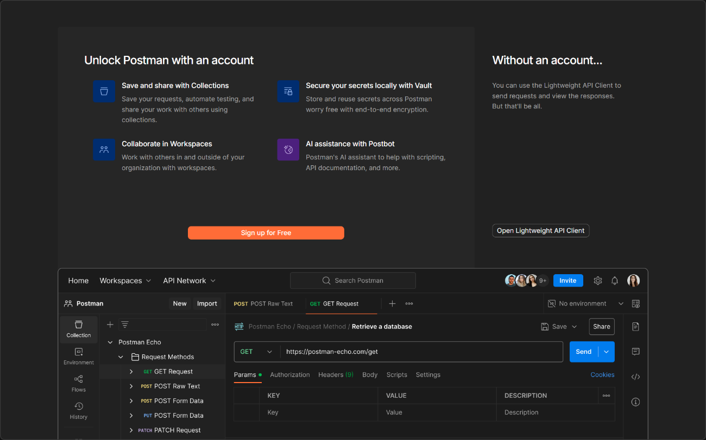

- You should now see this screen: 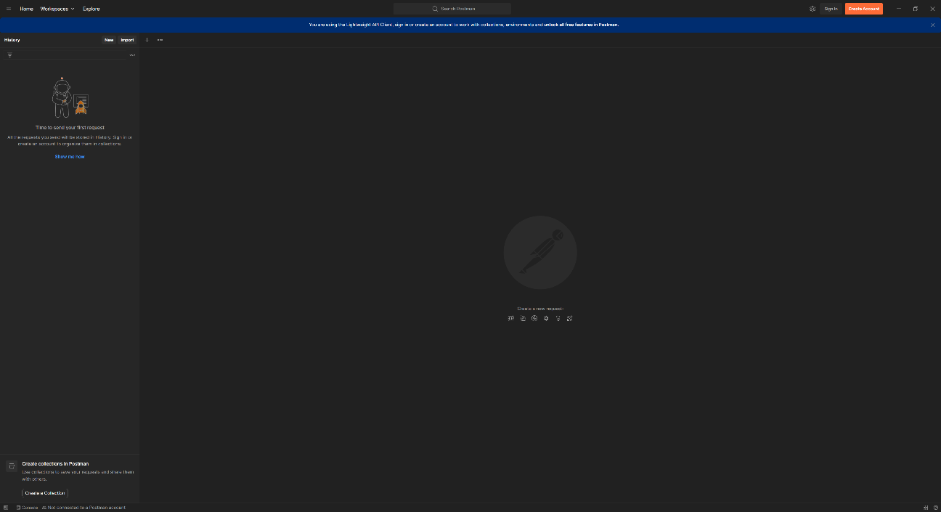

Creating your first request
- First click the little + in the top-left to create a new tab. 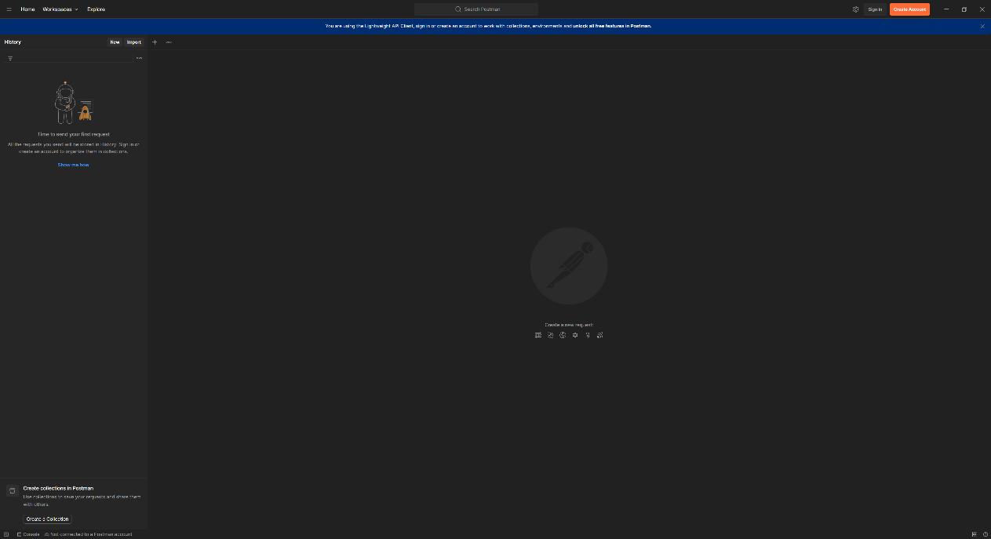

- You should now see this screen: 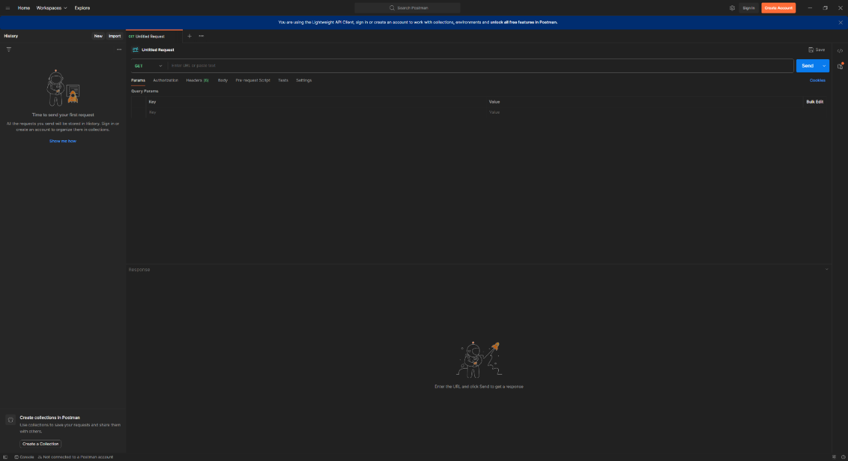

- Copy this URL and paste it into the bar at the top: https://api.restful-api.dev/objects 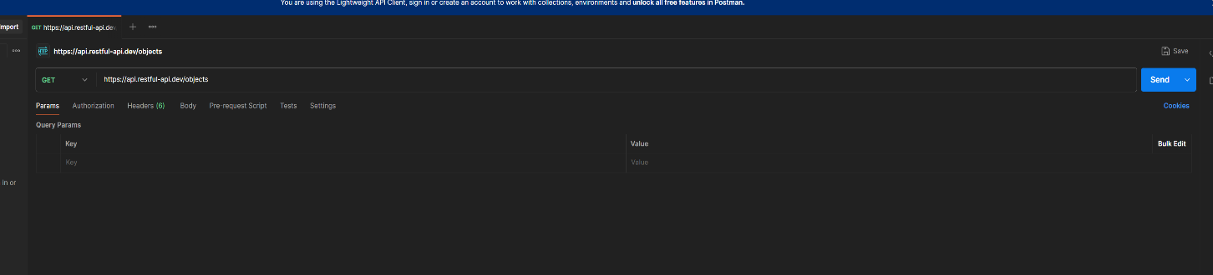
- Now hit Send and review the response. 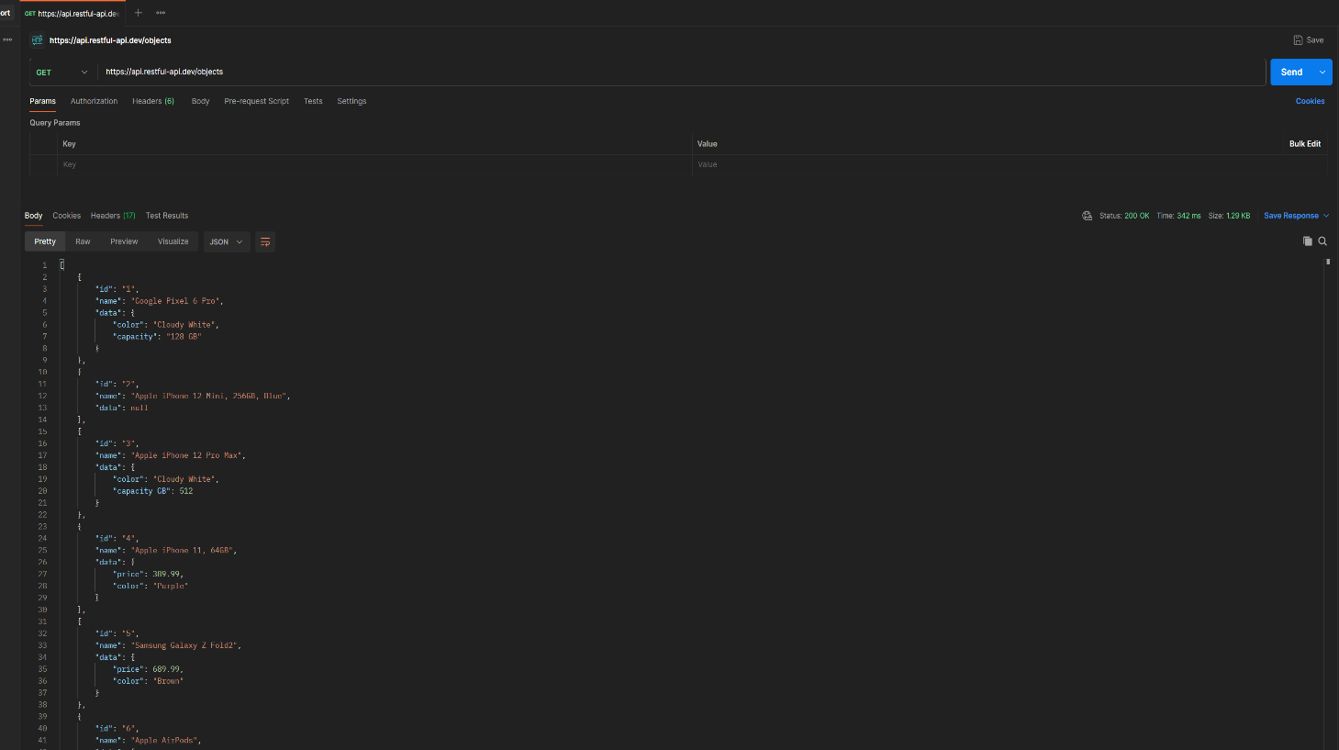

- You should see a JSON array containing a list of products and to the top right a status of 200 OK.

Sending data
In the previous exercise we looked at how to fetch data from an API. Now we are going to send some data.
- Hit the + again to create a second tab.
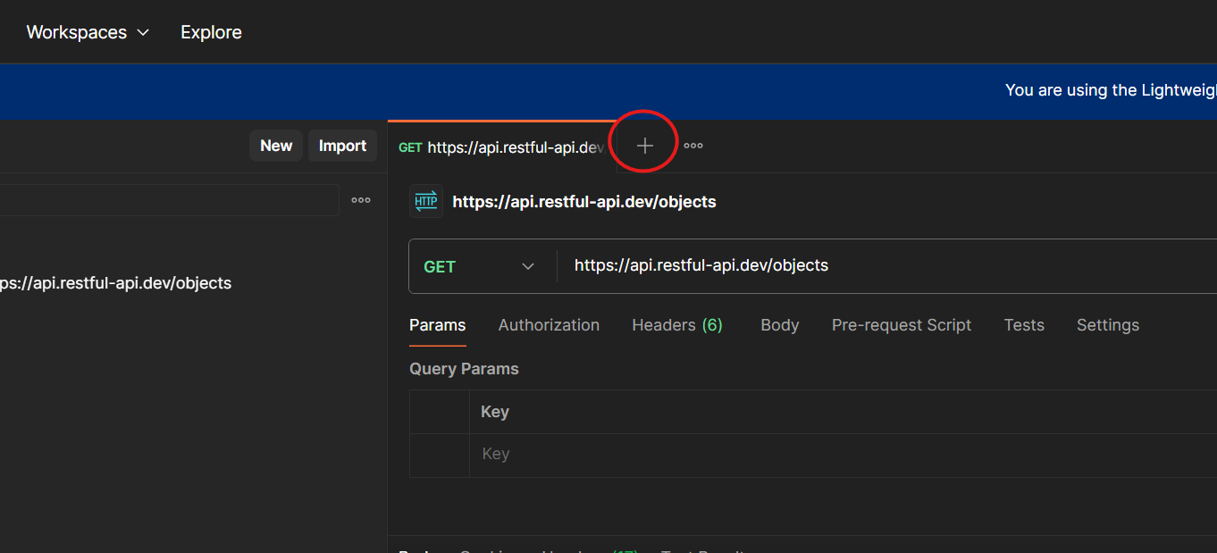
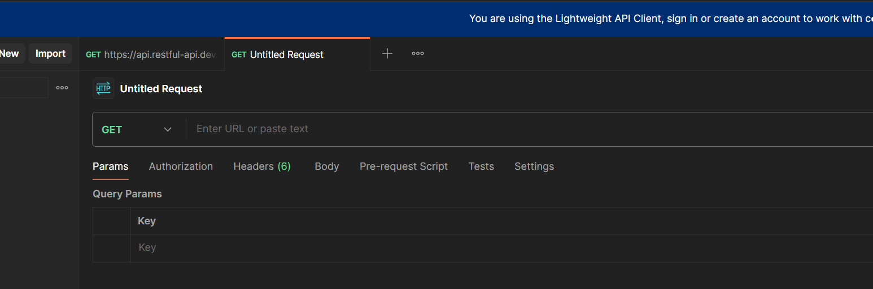

- Now change GET to POST. This will allow you to send data with your request.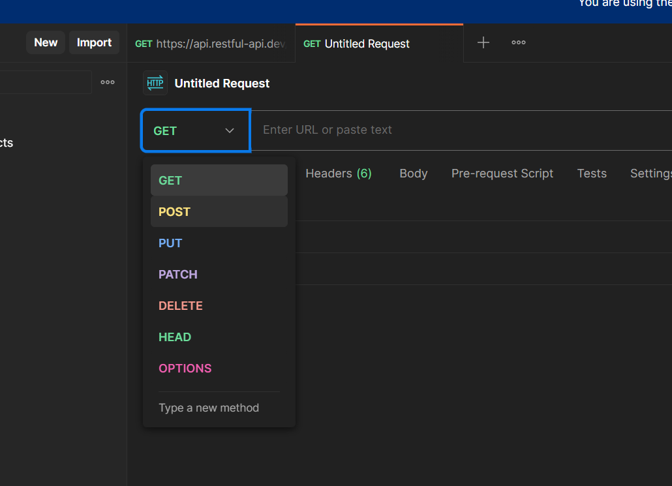 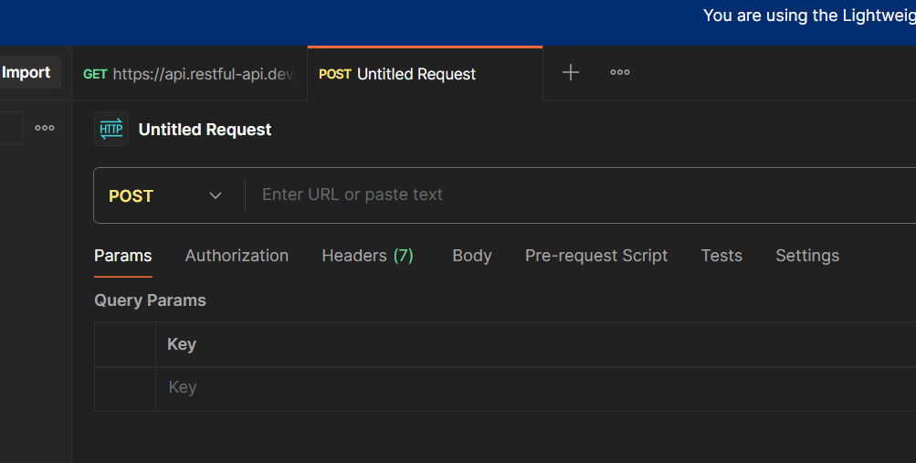
- Copy this URL and paste it into the bar at the top: https://api.restful-api.dev/objects 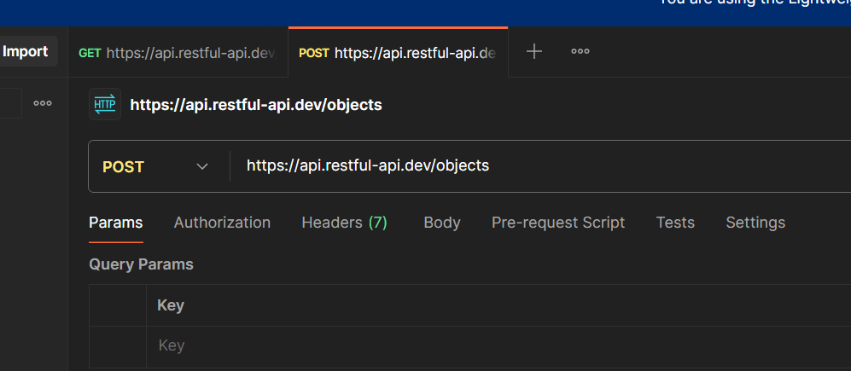

- Now select the Body and raw tabs. This will allow you to type in the data for your request body.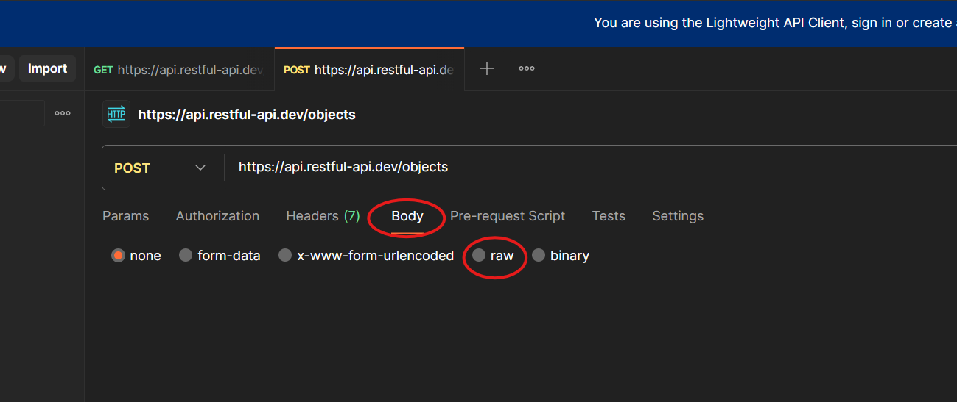

- Change Text to JSON as this is the actual data format we will be using.

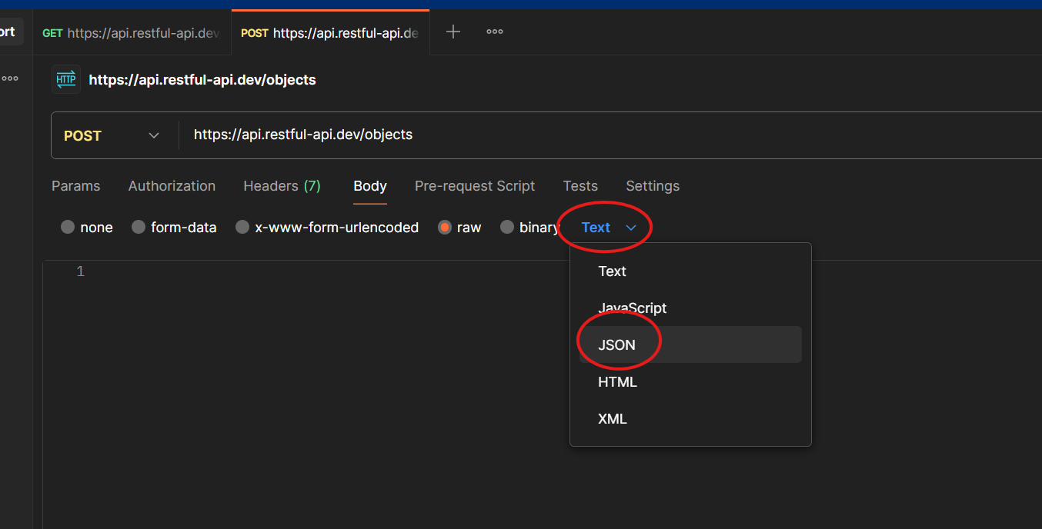

- Paste in this data:
{
"name": "Google Pixel 8",
"data": {
"year": 2023,
"price": 189.99,
"colour": "black",
"capacity": "128GB"
}
}

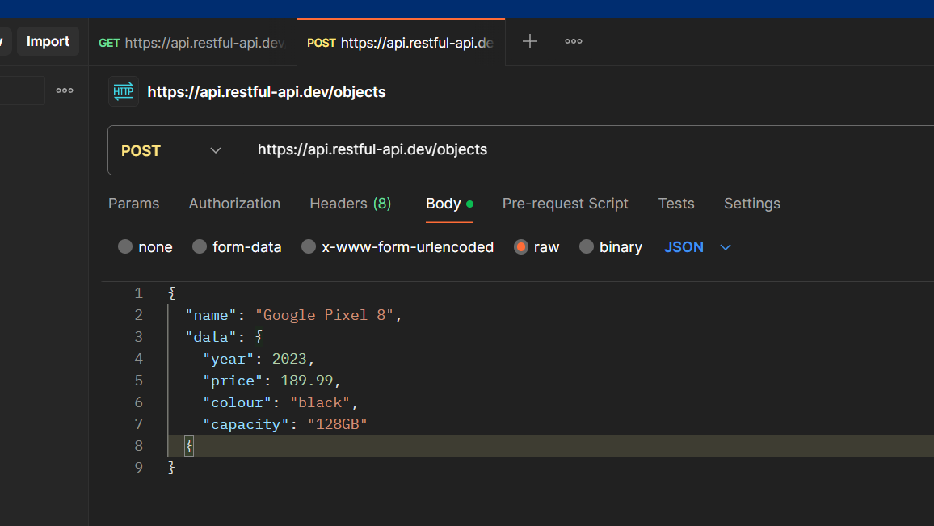

- Finally, hit Send and view the response.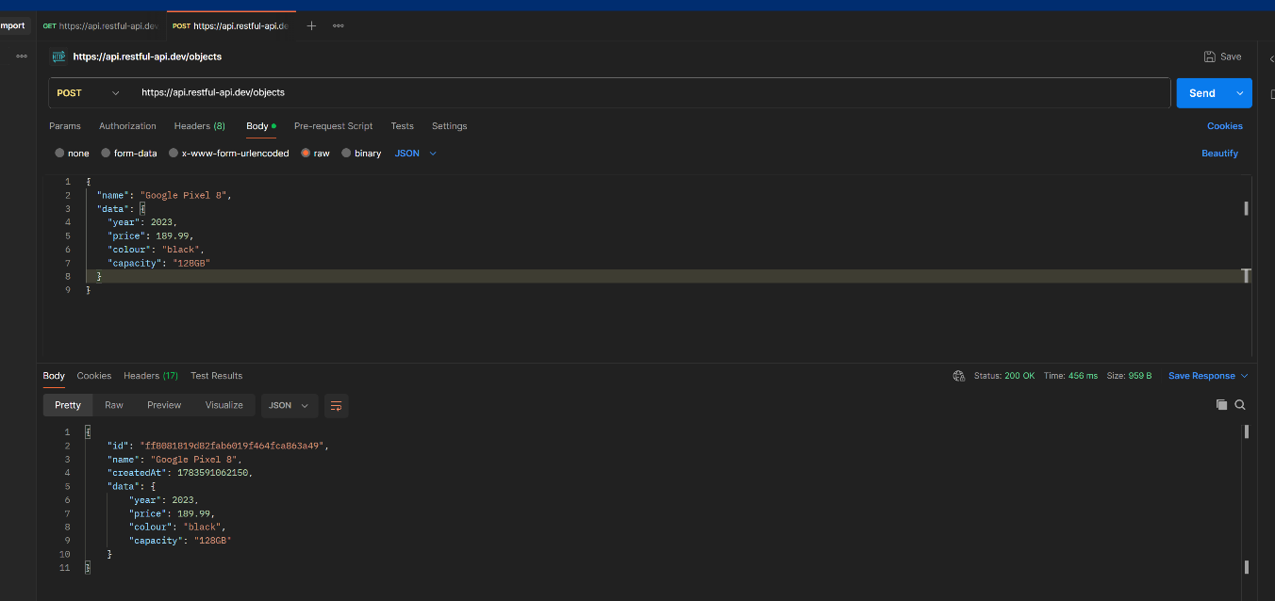

- You should see the data you entered but with an automatically generated ID.

Python

Get request
- Start by cloning the Git repository at https://github.com/JHarry444/AC0_Day10.git.
- Next, find the folder on your computer and open it as a PyCharm project.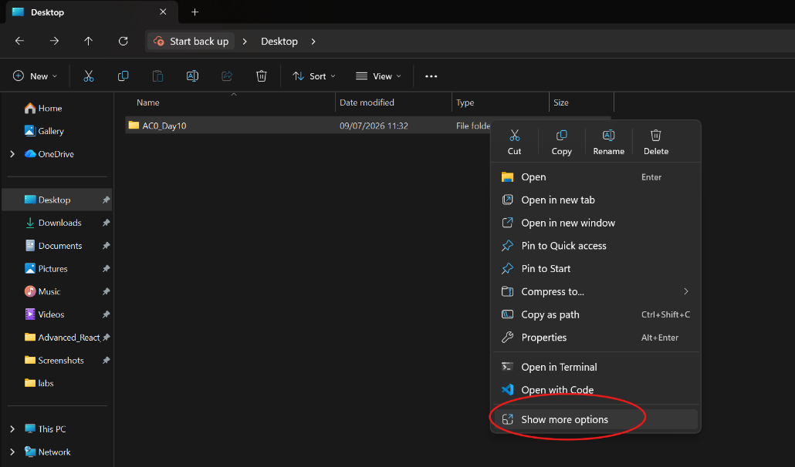
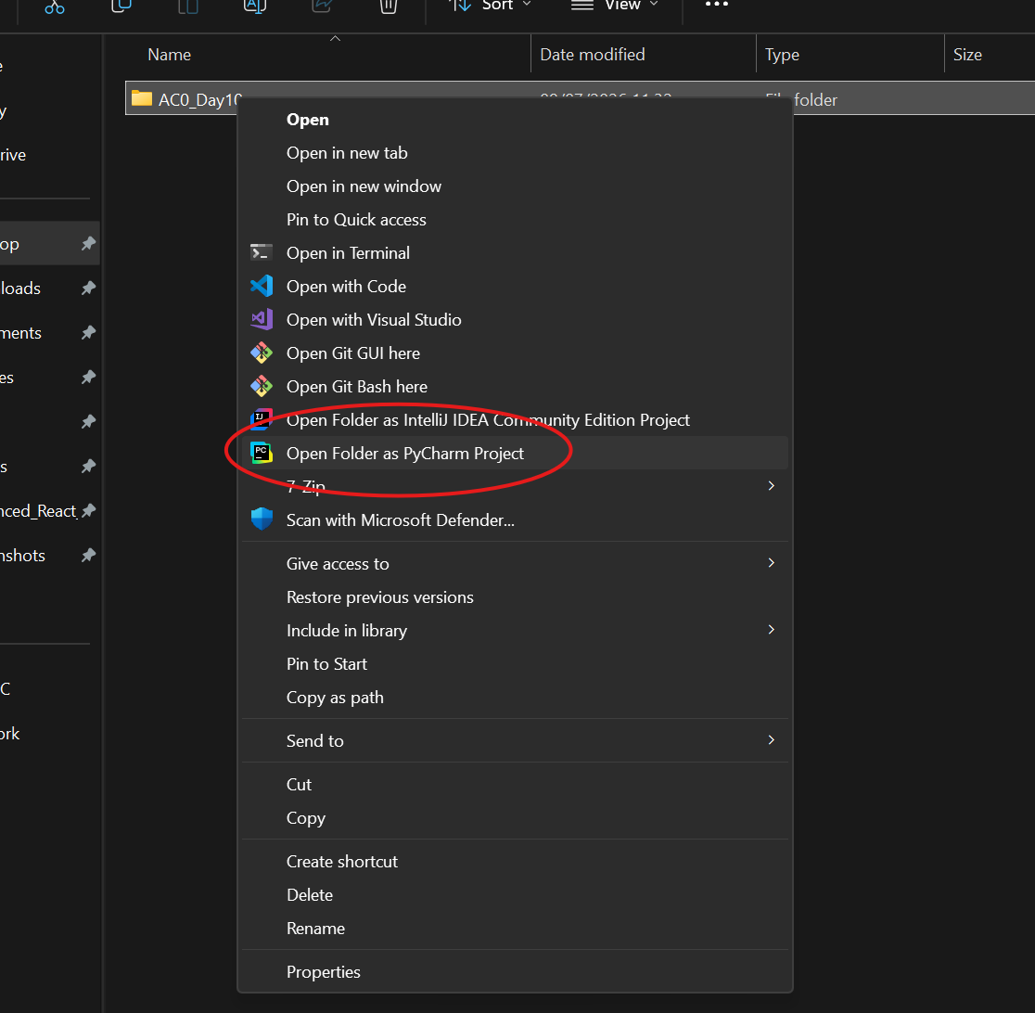
- If prompted, select Trust Project.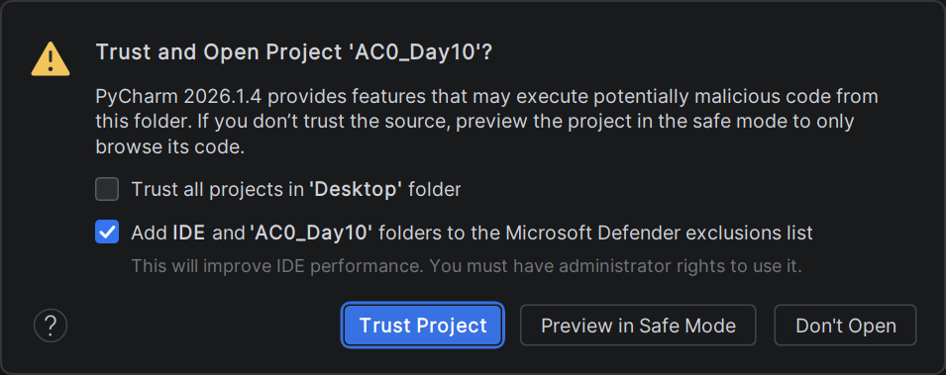

- You should now see this screen. If not, open main.py from the project browser on the left.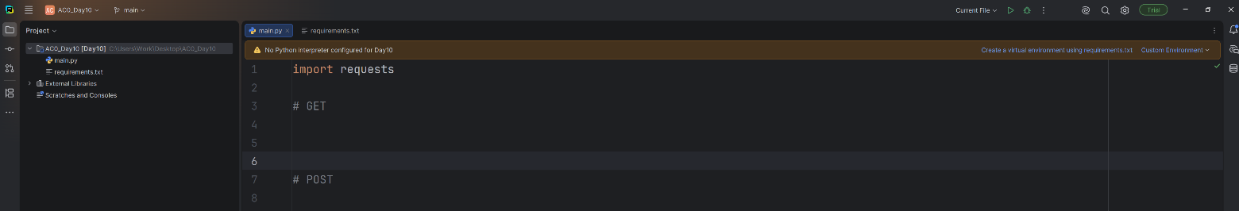

- After the #GET comment we’re going to add some code for making a GET request. Start by creating a URL variable and assigning it this string "https://api.restful-api.dev/objects".
- Next create a variable called res and assign it to requests.get(url). This will use the requests library to send a GET request to the restful API and store the response.
- Interrogate the response by printing res.status_code, res.headers[‘content-type’] and res.json().
- Last, assign res.json() to a variable called data and loop through it, printing each item individually.
- You code should look like this:
res = requests.get("https://api.restful-api.dev/objects")
print("Status:", res.status_code)
print("Headers:", res.headers['Content-Type'])
print("JSON:", res.json())
data = res.json()
for item in data:
print(item)

POST request
- Under the #POST comment, create a new variable called body and assign it this data:
{
"name": "Google Pixel 8",
"data": {
"year": 2023,
"price": 189.99,
"colour": "black",
"capacity": "128GB"
}
}

- Create a second response variable res2 and assign it to be requests.post('https://api.restful-api.dev/objects', json=body).
- Print out the status code and response body as you did before.
- Your code should now look like this:
# POST
body = {
"name": "Apple MacBook Pro 16",
"data": {
"year": 2019,
"price": 1849.99,
"CPU model": "Intel Core i9",
"Hard disk size": "1 TB"
}
}
print("Sending POST request:")
res2 = requests.post('https://api.restful-api.dev/objects', json=body)
print("Status:", res2.status_code)
print("Response Body:", res2.json())

